NAPIER UNIVERSITY SCHOOL of COMPUTING

Systems and Services

Unit 7

Processes

Operating Systems

and

Processes

Student Study Material

• Alastair Soutar •
• Alastair Soutar • School of Computing • Napier University • Edinburgh •

First published by Napier University, Edinburgh, Scotland © 2008.
No part of this publication may be reproduced, stored in a retrieval system or transmitted in any form or by any means – electronic, electrostatic, magnetic tape, mechanical, photocopying, recording or otherwise – without permission in writing from Napier University, 219 Colinton Road, Edinburgh, EH14 1DJ, Scotland

Overview
This unit introduces the basic structure and function of an operating system. It then looks at the sequence of steps involved in converting a program into a process. It introduces the concept of the process, a theme which will be explored in more detail in the next unit.

Learning Outcomes

On completion of this unit you should :

- Understand the concepts of logical and physical address spaces.

- Understand the organisation of processes in memory.

- Understand and further develop the ideas of processes.

Resources Required

Documentation
Course Notes

Project Software

Hardware

Additional Material

Tutorial : Processes

Learning Outcome
On completion of this tutorial you should understand the principles of processes and how this concept is related to programs and the running environment.

Use the unit coursenotes as a reference model when answering the following :

1. Describe the steps which occur in an operating system to take a program module and make it into an executable process.

2.
(i) Using an example explain the principle of the fetch/execute cycle.
(ii) Explain the terms logical address and physical address.

(iii) Draw a simple diagram showing the mapping of logical addresses to physical addresses.

3. A process can be considered as a sequential program in execution.
Explain the purpose of the elements of this dynamic entity, and you can use a diagram if you wish.

4.
(i) Describe the term re-entrant code.
(ii) Provide an example of a program using re-entrant code.
(iii) Discuss the function of the code segment in the example you have provided.

Practical :

There is no practical associated with this module. However, the simple commands tutorial from the Linux
unit should be used to familiarise the reader with tasks.

Operating Systems and Processes

Background

A computer system incorporates software that allows the user to interact with the hardware in the system in a convenient fashion.

USER USER USER

APPLICATIONS APPLICATIONS
PROGRAM PROGRAM

OPERATING SYSTEM

HARDWARE

Operating System

This is a collection of program modules which allow the system to operate efficiently. In particular, this software

- organises backing storage,
- organises memory
- handles peripherals
- interacts with users
- and allows access to utilities such as security, back-up, editors and compilers.

In the same way that hardware is split in to different components, in order to increase reliability, the programs or software of the computer system are also split to increase reliability and maintainability. Some of these modules will be covered in later units.

Virtual Machine

The Operating System presents a user-view of the system and not a hardware view of the system. Thus, a user using a high-level language to code a solution to a business problem, for example, is writing the program in the context of an ideal environment in terms of memory usage, peripheral usage, processor usage and utilities usage etc. In other words, the programmer does not have to concern themselves with these aspects of running the program and need only concentrate on the application itself. It is the responsibility of the operating system to create this situation and to link in the required hardware components as they are required to enable the program to run. If it manages to do this successfully, then it will increase programmer efficiency and system efficiency. This unit will look at how it prepares a program for running on the system and later units will look at how it handles the use of the hardware.

Processes

The process is the main idea of “activity” or “work” in the Operating System. The operating system wants to allocate the processor to these units of work so that the processor is used efficiently. A system process called the scheduler will pick a suitable process to occupy the processor. This scheduler will ‘continually’ inspect the processor queue to ensure that the most appropriate process is given access to the processor. Events in a computer are indicated by interrupts which cause the system to pause and decide what to do next. This will usually cause the scheduler to look at the processes in the process queue.

Thus, the sequence of activity inside the Operating System can be viewed as a cycle of “processes”:
sBisCisDisEisBisCisDisEisBisCisDisEisBisCi ... etc.,
where B, C, D and E are user or system tasks of some sort, and s and i are the scheduler and interrupt controller from the Operating System kernel, respectively.
So, the scheduler runs and decides which process or task to run next and that process is then given access to the processor. What this means is that the program counter is pointing to instructions from that process or task (e.g. B), and the other registers hold data from that process. When an interrupt occurs, the “context” switches to another process and the registers will now contain information from that other process.

However, programmers write programs and do not think about processes. It would be useful to see if there is any connection between the two entities.

Programs and Processes

This section explains:
. the relationship between programs and processes,
. the constituents of a process in the computer, and
. how decisions are made about which process should run.

From program to process -1

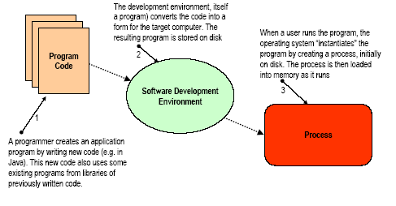

From program to process -2

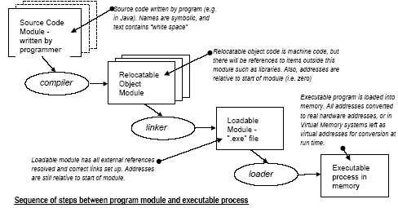

The programmer writes modules in a programming language (e.g. Java).These modules may refer to other modules written earlier (e.g. library modules containing maths functions, or code modules created by colleagues). The final “program” could contain several modules and is produced by:

. “compiling” - translating from the text of the language to machine code, and,
. “linking” - bringing a set of modules (each of which may have overlapping addresses) together into one program, with a single range of addresses.

By convention, to make it easier to write programs for any computer, the linked program has a logical address space, starting from zero. All of the instructions, data and resources used by the process are addressable by references to points (addresses) in that space.
The program is now represented by a file, probably stored on a disk.
Typically this is called “something.exe” meaning the file is “executable”.
To run the program, a user would click on the icon for something.exe on the desktop, or type a command of the form, “run something.exe”.
The operating system then creates a process for the program.

The process for the program is created initially on the disk in an area of the disk called the “swap” file or “page” file (e.g.“pagefile.sys” in NT/XP)
The process has a logical address space which starts at zero and covers every address up to a maximum of 4GB. Clearly, no ordinary computer can hold such a large process in memory. The memory is a “physical address space” (typically 128-256 MB).
To run the process, portions of it are copied (or “loaded”) from disk into memory as they are needed. The portions are called “pages”. During loading, the logical addresses of the program are “mapped” to the physical addresses of the part of memory used to actually store the code or data.
If a program is run several times there is no guarantee the same physical memory will be used each time. Every logical address must be converted individually each time the program is run. This conversion can be done by memory management hardware.

Mapping logical to physical addresses

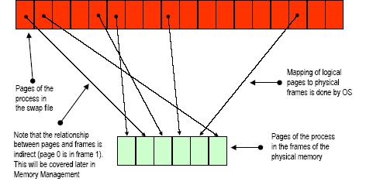

The Fetch/Execute model, studied previously, shows how instructions and data are stored in memory and “read” from there into the CPU as the program, or more properly, process, runs. As well as instructions and data embedded in the program, every device or service, with which a program interacts, appears as an address, or a set of addresses, in memory. Some examples are given below.

When a process reads the keyboard it fetches a value which has been placed in a certain memory location by the keyboard hardware.
Displaying a character means writing the character into another memory location from which the display hardware will put it on the screen.
Reading a disk file means that the hardware controlling the disk copies blocks of data from the disk, and stores them in a range of memory locations in the address space from which the program can “read” them.
As the program is running, the logical address space of the program must be mapped by the Operating System on to real physical hardware addresses.

The following diagram shows the relationship between the two address spaces.

Program Address Space
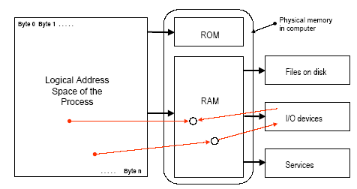

Programs and Processes

A Process is a unit of processing. It can be scheduled (allocated to a processor) when its resource requirements can be met (i.e. all devices needed are free), and a processor is available.
A Resource is any component of the system needed by the process as it executes, for example, memory, display devices, input devices, network connections. All resources have interfaces that define how they can be obtained and used.
A File is a unit of information storage. In effect, it is a special form of resource. Files hold information to be manipulated or created by processes. As before, the file storage sub-system has a defined interface.

The accompanying diagram shows how these items are interconnected.

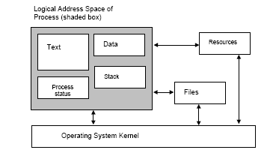

A Program is a static entity consisting of a generalised behaviour described by statements and generic data.
A Process can be considered as a sequential program in execution. It is therefore a dynamic entity, comprising:
. “machine” code defining the behaviour of the process. This is usually held in the “Text segment” of the process.
. Data being used by the process. The “Data segment” holds static data
(e.g. data may be obtained from outside the process (from a file or other
resource), while the “Stack segment” holds dynamic data (e.g. variables created
while the program is running).
. Process status - housekeeping details plus the register save area.
. Links to Files and other Resources being used by the process.
To expand on this theme, the distinction exists in other areas where there are examples of static generalised behaviour encoded in rules or instructions, and specific instances of dynamic activity arising from it.

A recipe for a pasta dish is a program.
Making a specific dish of that pasta from that recipe is a process.
A knitting pattern for a sweater is a program.
Making a particular red sweater form that recipe is a process.
Plans for a detached house are a program.
Building a specific house on a specific site is a process.

In each case the specific instance of the process accepts inputs (pasta, wool or bricks) and produces outputs (food, sweater, house).
In the same way, a word processor is the generalised behaviour needed to write a document.
Using it to produce a specific report requires a process to run which accepts inputs from the keyboard and files and generates the report file.

Re-entrant (or shareable) programs

If several copies of the same program are running simultaneously, the code segments will be the same. Obviously, this wastes physical memory space.
Some language compilers produce what is known as “re-entrant code.”
With this technique, the code segment of each process is replaced by a link, or pointer, to a single code segment which can be used by several processes simultaneously. Thus we have several processes sharing a single program text.
However, as before, each process has its own data, resources and status.
Each process will produce a different (correct) result from applying the same program to different sets of data.

As an example, suppose a program reads two integer numbers, x and y, and displays their sum.

The data segment for process 1 might hold 3, 4 and the sum: 7
The data segment for process 2 might hold 150, 200 and the sum: 350
Each process would share the same code segment with sum := x + y

When process 1 is running the addresses for x and y are in its data segment.
When process 2 is running the addresses for x and y will be in the data
segment for process 2.

End of Unit - Summary of Achievements

On completion of this unit you should have achieved the following :

On completion of this unit you should :

- Understand the concepts of logical and physical address spaces.

- Understand the organisation of processes in memory.

- Understand and further develop the ideas of processes.

